Research Paper/Report Template for Undergraduate AI/ML Projects

Introduction (3+ pages, 5–6 paragraphs)
Goal: Make the reader care about your narrow problem.
Narrative Arc: Problem → Why unsolved → How we solve it → Why it matters.
Para  graph | Content & Length | Storytelling Tips
1 | - Broad domain context (½ page)  - Define AI/ML’s role in [field: e.g., agriculture, finance]  - Cite 2–3 high-impact stats (e.g., “AI market in healthcare to hit $188B by 2030”) | Start big → zoom in. Use WHO/World Bank/Gartner stats.
2 | - Narrow topic focus (¾ page)  - What specific problem? (e.g., “crop disease detection from leaf images”)  - Why this sub-problem matters (cost, lives, efficiency) | Use a real-world anecdote: “In Pakistan, 30% wheat yield lost to rust…”
3 | - Research gap & motivation (1 page)  - Critique 3–4 prior works: “Author X used SVM but ignored class imbalance…”  - Quote limitations directly from papers  - Emphasize why now? (new data? compute? algorithms?) | Contrast: “While CNNs excel in ImageNet, they underperform on small agricultural datasets due to overfitting.”
4 | - Your contribution (¾ page)  - Start: “In this research, we…”  - Aim: “to develop a robust classifier for [task]”  - Dataset(s): name + source (e.g., “PlantVillage dataset, 54k images”)  - Key techniques: “SMOTE balancing + ResNet50 + RF ensemble”  - Top result: “achieved 98.2% F1-score” | Be specific! Avoid “we used ML.” Say which ML and why.
5 | - Novelty & extra findings (½ page)  - What’s new? (e.g., “first to apply Vision Transformers to Pakistani wheat rust”)  - Unexpected insights (e.g., “color histograms outperformed texture features”) | Highlight student-level innovation: “Our lightweight model runs on mobile devices.”
6 | - Paper roadmap (2–3 lines)  - “Section 2 reviews related work.  - Section 3 details our methodology…” | Standard closing.

Literature Work or Related Work - (4–5 pages)
Goal: Show you’ve mastered the field—and found a gap to fill.
- Paragraph 1 (1 page):
- Synthesize trends: “Three approaches dominate: (1) traditional ML (SVM, RF), (2) CNNs, (3) hybrid models.”
- Critically compare: “SVMs are interpretable but fail on raw pixels; CNNs need big data.”
- Cite 8–12 papers (mix of seminal + recent).
- Subsections by Technique (2–3 pages):
- 2.1 Traditional ML in [Domain]
  - Summarize 3–4 studies using SVM/RF/KNN
  - Note datasets, accuracy, flaws
- 2.2 Deep Learning Approaches
  - Cover CNN/RNN/LSTM papers
  - Mention transfer learning (e.g., ResNet, BERT)
- 2.3 Data-Centric Challenges
  - Discuss class imbalance, small datasets, noise handling
- Comparison Table (1 page):
Study | Dataset | Method | Accuracy | Limitations
Khan et al. (2023) | PlantVillage | SVM | 89% | No balancing
Lee (2024) | Custom | ResNet50 | 94% | Needs GPU
Ours | PlantVillage + Aug | CNN+RF | 98.2% | Mobile-ready

Key: Don’t just list papers—critique them to justify your method.

Proposed Research Methodology (2~4 Pages)
Goal: Reproducibility + clarity.
- Text Content:
- Dataset description (source, size, classes, features)
- Preprocessing steps (handling missing values, text cleaning, image resizing)
- EDA highlights (e.g., “class distribution showed 80:20 imbalance”)
- Class balancing: SMOTE, ADASYN, or undersampling
- Normalization: Min-Max, Z-score
- Train/test split (e.g., 80:20, stratified)
- Framework Diagram (mandatory):

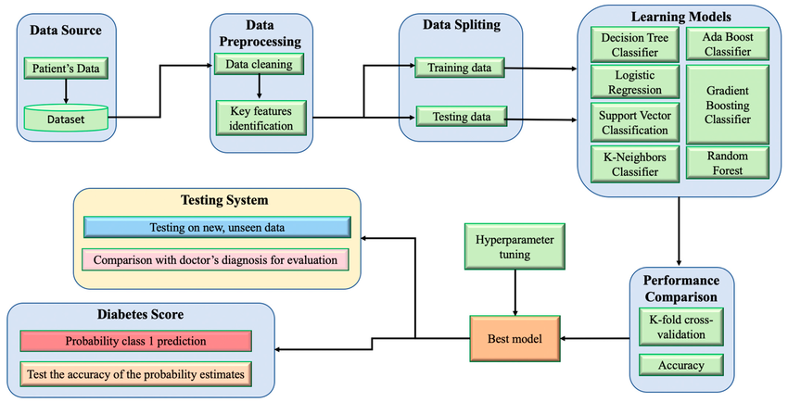
Figure 1: Exampe 1 of Framwork
Follow this sequence to draw a good framework diagram:
- Raw Dataset
- Preprocessing
- EDA & Visualization
- Feature Engineering
- Class Balancing
- Normalization
- Train/Test Split
- Model Training
- Evaluation
You can use MS-VISIO, E-Draw, or any offline-online tool to make a self-explanatory diagram of your experiment/research.

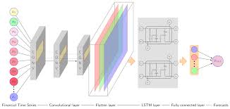
Figure 2: Exampe 2 of Framwork
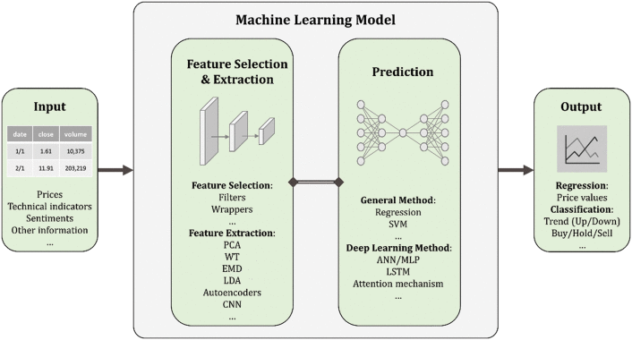
Figure 3: Example 3 of Framework diagram

Algorithm
Why you select these algorithms for your experiment or research
Structure of this section:
- 4.1 Machine Learning Models
- Naive Bayes: “Chosen for baseline due to speed on text data”
- SVM: “Effective in high-dimensional spaces like TF-IDF vectors”
- 4.2 Ensemble Methods
- Random Forest: “Reduces overfitting via bagging; handles mixed features”
- AdaBoost: “Focuses on hard-to-classify samples”
- 4.3 Deep Learning Models
- MLP: MultiLayer Perceptron
- ANN: Artificial Neural Network
- CNN: “Captures spatial hierarchies in images”
- LSTM: “Models sequential dependencies in time-series/text”

Experimental Setup (1 page)
Explain these topics in this section:
- Dataset Stats: Rows, columns, class distribution, sample images/text snippets
- Hardware: CPU/GPU, RAM (e.g., “Intel i7, 16GB RAM, NVIDIA GTX 1650”)
- Software: Python 3.9, scikit-learn 1.3, TensorFlow 2.12
- Hyperparameters: Learning rate, epochs, k in KNN, tree depth in RF

Performance Evaluation Measurement
- Metrics Defined:
- Accuracy, Precision, Recall, F1-Score (with formulas)
- ROC-AUC for probabilistic models
- Confusion matrix interpretation
- Visualizations:
- Heatmap of correlation matrix
- Accuracy (Training with respect to Testing)
- ROC curves for top 3 models
- Bar charts comparing F1-scores across algorithms
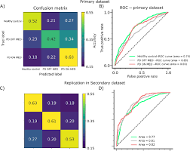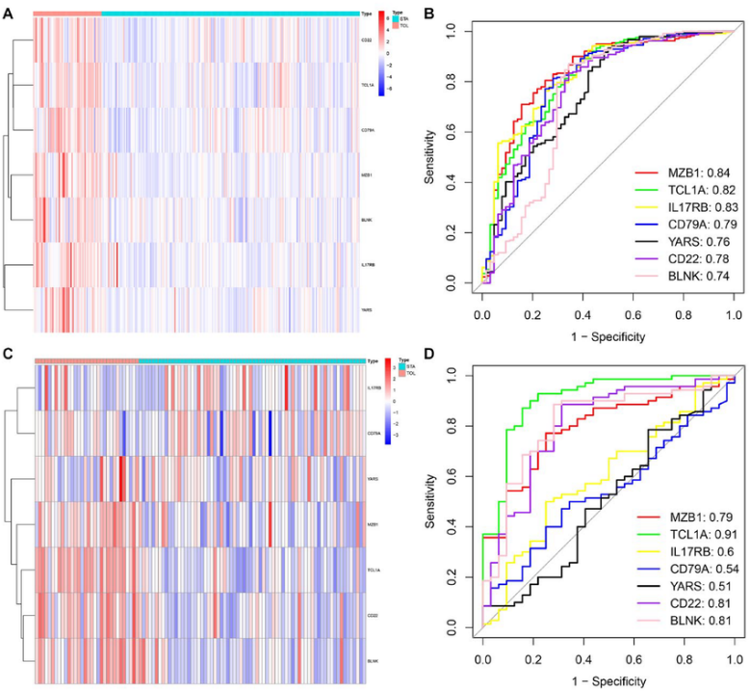

- Statistical Tests (optional but impressive):
- t-test to confirm significance of improvement
Golden Rule: Every metric must link to a business/real-world implication (e.g., “High recall critical for disease screening to avoid false negatives”).

Results and Discussion (50% of total paper → 5~6 pages)
Goal: Interpret—not just report—results.
Discussion = Insight: Answer why results happened, not just what.
Structure of this section:
- 7.1 Baseline Comparison: “Our CNN+RF (98.2%) outperforms SVM (89%) by 9.2%—validating ensemble benefit.”
- 7.2 Ablation Study: “Without SMOTE, F1 dropped to 82%—proving balancing is essential.”
- 7.3 Error Analysis: “Misclassifications occurred in early-stage disease images (visually ambiguous).”
- 7.4 Computational Efficiency: “RF trained in 2 mins vs. CNN’s 45 mins—trade-off between speed and accuracy.”
- 7.5 Real-World Applicability: “Model deployed on Android achieves 95% accuracy—viable for farmers.”
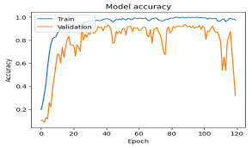

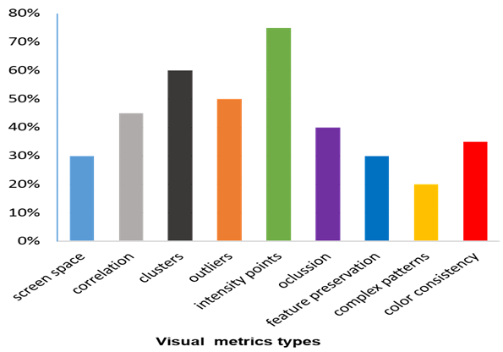

Conclusion (½ page, 1 paragraph)
- Restate problem + your solution
- Highlight best result (“98.2% F1-score”)
- Emphasize novelty (“first mobile-deployable model for X”)
- Suggest future work (“extend to video input”, “test on drone imagery”)
Never introduce new info here. Only synthesize.

Abstract or Summary
- Length: 150–250 words (≈6–8 lines)
- Structure (4 sentences):
- Problem & Motivation (1 sentence): “Early diagnosis of [X] remains challenging due to [Y].”
- Gap in Literature (1 sentence): “Existing methods suffer from [limitation], especially in [context].”
- Your Approach (2–3 sentences): “We propose a novel pipeline combining [technique A] and [technique B] on [dataset]. Our methodology includes [key steps: e.g., SMOTE balancing, GloVe embeddings].”
- Key Result & Impact (1–2 sentences): “Our model achieves [metric]% accuracy—outperforming baselines by [%]. This enables [real-world application].”

Title of Article
- Length: One line (≤15 words)
- Content: Clear, specific, and evocative. Include:
  - Domain (e.g., healthcare, sentiment analysis)
  - Task (e.g., classification, prediction)
  - Novelty or key technique (e.g., “using ensemble deep learning”)
- Example:
“Early Detection of Diabetic Retinopathy Using Hybrid CNN-RF Models on Fundus Images”

Tips for Students:
- Story > Perfection: A clear narrative beats complex math with no context.
- Visuals are King: 1 good diagram = 100 words.
- Cite Everything: Even preprocessing steps (e.g., “SMOTE [Chawla et al., 2002]”).
- Write Abstract Last: After results are final.
- Deploy = Wow Factor: Even a simple Flask web demo impresses reviewers.

